***Features***

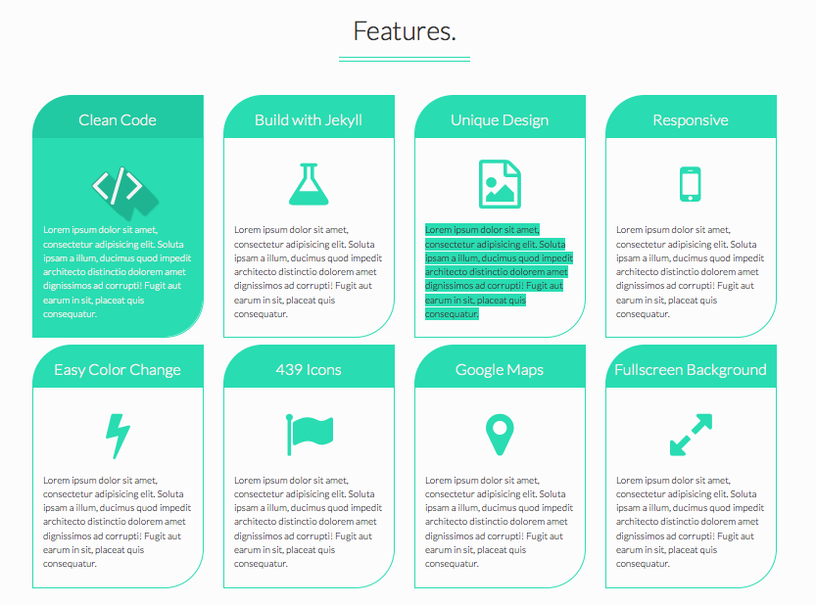

|  |  |  |  |
| --- | --- | --- | --- |
| Zero Programming  Know-How Needed | Build with AppYolk | Templates | Step by Step |
| Not familiar with C++, JAVA or PHP?  These are not requried in building your Mobile Applications with us.  We embed it for you! | AppYolk’s proprietary system provides an unique ‘one-of-its’ kind’ setup for end users | With a vast amount of templates to choose from. Makes its hard to have a clash in style for every app. | Guidance is important when you need to build a successful app.  We make sure you don't miss a single step. |
|  | | | |
| One Click | Products Placement | Multi Platforms | Payment Gateway |
| One-Click to Weblink, Contact Number, Email, Maps. | One of the most important “P” in marketing. Products!  Show off your products and let your target audience know they need you! | Appyolk features setup for 2 largest platform- iOS & Android. | The fastest mode of payment available in the M-Commerce.  Have them shop fast and get out of the way. Next Please! |

***Sign Up***

Email

Full Name

Password

Confirm Password

***Services change to Support By:***

*** ***